# **Components of Brake System**

Brake systems components are grouped into below categories:

* Energy Supply System
* Actuation Devices
* Force Transmission
* Wheel Brakes

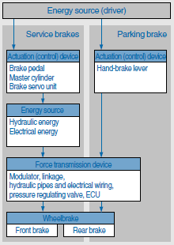

## Energy supply system

The energy supply system encompasses those parts of the braking system that provide, control and (in some cases) condition the energy required to operate the brakes. It ends at the point where the force transmission system begins, i.e. where the various circuits of the braking system are isolated from the energy supply system or from each other. Car braking systems are in the main power assisted braking systems in which the physical effort of the driver, amplified by the vacuum in the brake servo unit, provides the energy for braking.

## Actuation device

The actuation device encompasses those parts of a braking system that are used to initiate and control the action of that braking system. The control signal may be transmitted within the actuation device, and the use of an additional energy source is also possible. The actuation device starts at the point at which the actuation force is directly applied. It may be operated in the following ways:

* By direct application of force by hand or foot by the driver,
* By indirect control of force by the driver.

The actuation device ends at the point where distribution of the braking-system energy begins or where a portion of that energy is diverted for the purpose of controlling braking. Among the essential components of the actuation device are the vacuum servo unit and the master cylinder.

## Force transmission system

The force transmission system encompasses those parts of the braking system that transmit the energy introduced by the energy supply system(s) and controlled by the actuation device. It starts at the point where the actuation device and the energy supply system end. It ends at the point where it interfaces with those parts of the braking system that generate the forces that inhibit or retard vehicle motion. It may be mechanical or hydro-mechanical in design. The components of the force transmission system include the transmission medium, hoses, pipes and, on some systems, a pressure regulating valve for limiting the braking force at the rear wheels.

## Wheel brakes

The wheel brakes consist of those parts of the braking system in which the forces that inhibit or retard the movement of the vehicle are generated. On car braking systems, they are friction brakes (disc or drum brakes).

